Fall 2020

CNS180

Introduction to Systems Development
Assessment R

Date:

Student Name | Student ID

Feedback/Comments:
S | Topic | Max Points | Earned Points | Feedback
1 | Task 1 | 20
2 | Task 2 | 25
3 | Task 3 | 20
4 | Task 4 | 5
5 | Task 5 | 20
6 | Task 6 | 10
 | Bonus | 5

Total Grade
100

Task1. (10 pts each *2 = 20 pts)

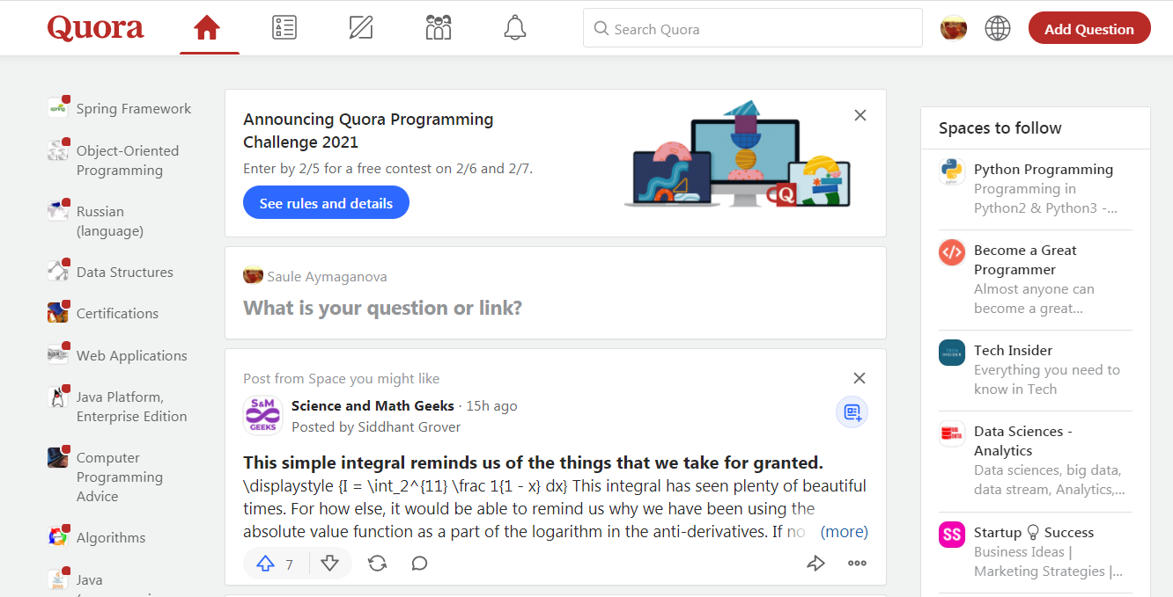
www.Quora.com
Quora is an American question-and-answer website where questions are asked, answered, followed, and edited by Internet users, either factually or in the form of opinions.
The company was founded in June 2009. In 2020, the website was visited by 590 million unique people a month.
Analyze this web-site, create login, try to follow some spaces, and read popular questions and answers. Try to make your own search for the question that interests you.

a) In chapter 1 you have learned about 5 components of the system. Describe the 5 components of the system for Quora: Data, People, Hardware, Software, Processes.

Solution:

b) In chapter 1 you have learned about 5 IS categories. How do you think, which category belongs Quora? Explain your opinion.

Solution:

Task2: (5*5 = 25 pts)
You need to describe system requirements for Quora. Describe 3 requirements for each requirement category (Input, Output, Process, Performance, and Security):

Input:
1.
2.
3.
Output:
1.
2.
3.
Process:
1.
2.
3.
Performance:
1.
2.
3.
Security:
1.
2.
3.

Task 3. (20 pts)
Given Class diagram. Draw object diagram on paper. Create a customer Abzal(his name is Abzal). He made 2 orders. First order contain Juice and Popcorn. Second order contains Chocolate bar and Milk. (Other details you can add yourself.)

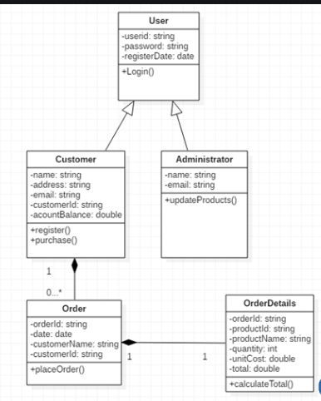
Solution:

Task4. (5 pts)
Given class diagram for animal. Draw object diagram:

Book
Author
Title
Price
Number of pages
Buy()
Read()

Solution:

Task5. (20 pts)
Given class diagram, draw object diagram for below use-case (story) Draw on paper, and post it below.

Use-case (Story):
There two camp Sites: Green Island, and Ahmadi Zoo. 3 camping Trips: two of them to the Green Island, and one of them to the Ahmadi Zoo.
There are 2 Scouts: Alima (she is normal Scout) and Hamza (he is Wealthy Scout, he donated 2000 KD).
Alima has only one awarded Badge – that is Beginner badge (e.g. badge specification name: “beginner”).
Hamza has two awarded badges - Beginner Badge, and Canoeing Badge.

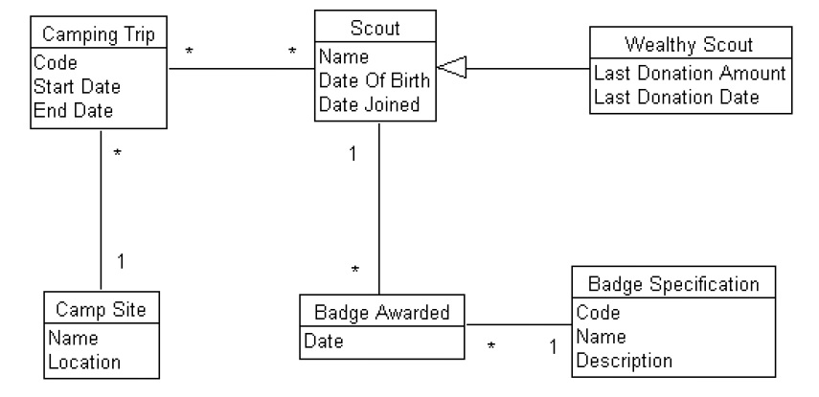

Solution:

Task 6 (5 pts each * 2 = 10 pts)
a) Draw activity diagram for a process: How to add question in Quora. There are many options available in Quora: question type – public, anonymous, etc., including link to the question, share Link, etc.

b) Explain your activity diagram.

Solution:

Bonus: (5 pts)
Draw the class diagram represented by the following.

Room (Room number, Room type, number of beds, and number of rooms)
Booking (booking id, booking date, Amount to pay, number of days to stay in, room id)
Customer (name, gender, age)

Customer makes booking. Booking reserves a room.

